2.1 Equation of Lines
Linear function y = f(x) = mx + b.
m is the slope and b is the y-intercept
Given two points (x1, y1) and (x2, y2), m = (y2-y1) / (x2 - x1) = rise / run

Linear Functions

For this class, we're going to learn a few ways to find an equation for the line. To do this, we either need to know (1) two points or (2) a point and the slope.

Point-slope form
Given a line with slope m passing through the point (x₁, y₁), the point-slope form of the line is y-y₁=m(x- x₁)

Example: Determining the point-slope form of a line
Find an equation of the line passing through the points (−2, −3) and (1, 3). Plot the points and graph the line by hand.

m = (3 - (-3)) / (1 - (-2)) = 6 / 3 = 2
y-y₁=m(x- x₁)
y - (-3) = 2(x - (-2))
y + 3 = 2(x + 2) y + 3 = 2x + 4 => y = 2x + 1

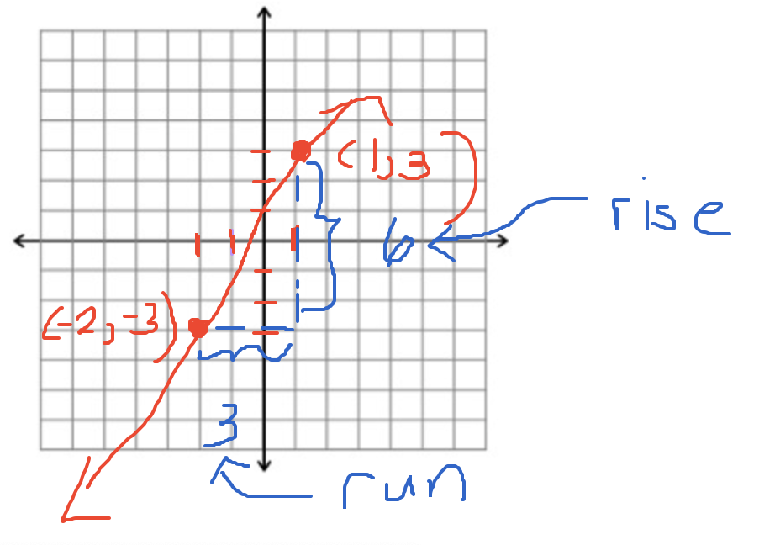
Find the point-slope form of the line passing through (1, 2) and (3, 5).

m = (y2 - y1) / (x2 - x1) = (5 - 2) / (3 - 1) = 3 / 2

Equation of the line (point-slope form)
y-y₁=m(x- x₁)

y - 2 = (3/2)(x - 1)
y - 5 = (3/2)(x - 3)
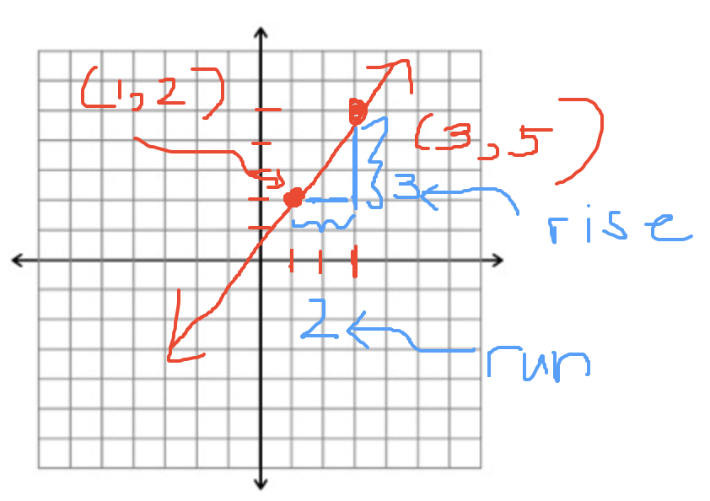

Slope-intercept form
Given a line with slope m and y-intercept (0, b), the slope-intercept form of the line is
y = mx + b

Example: Finding the slope-intercept form of a line
Find the slope-intercept form of the line passing through the points (−2, 1) and (2, 3).

Find the slope first.
m = (y2 - y1) / (x2 - x1) = (3 - 1) / (2 - (-2)) = 2 / 4 = 1 / 2

Replace m by the number we found.
y = (1/2)x + b

The next step is to solve for b. When x = -2, y = 1. Let's plug these values into the equation.

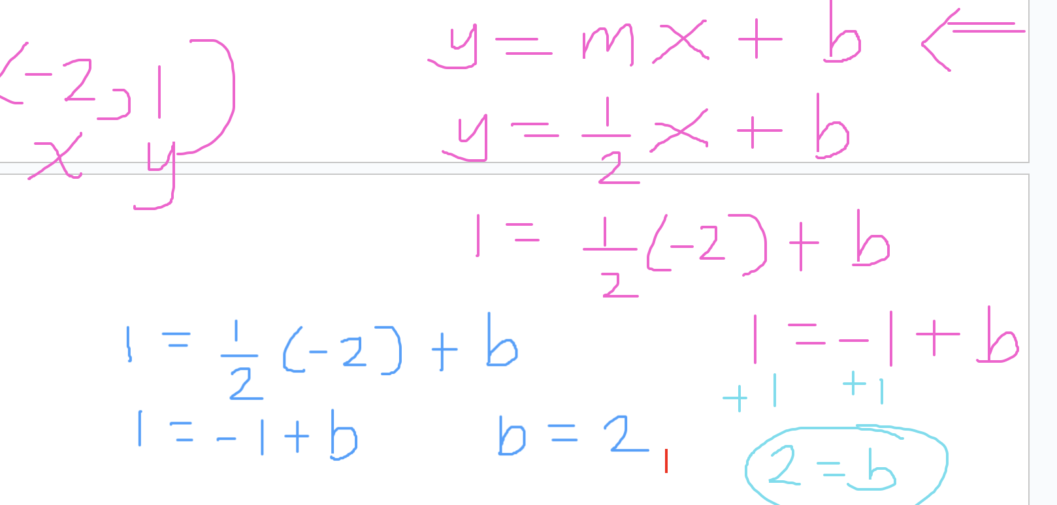

Equation in slope-intercept form.

$y = \frac{1}{2}x + 2$

Example: Find the slope-intercept form of the line that passes through (1, 5) and (2, -2)

m = (y2 - y1) / (x2 - x1) = (-2 - 5) / (2 - 1) = -7 / 1 = -7

y = mx + b

Substituting m = -7 into the equation gives us
y = -7x + b

x = 2 and y = -2.

-2 = -7(2) + b
-2 = -14 + b
12 = b

y = -7x + 12

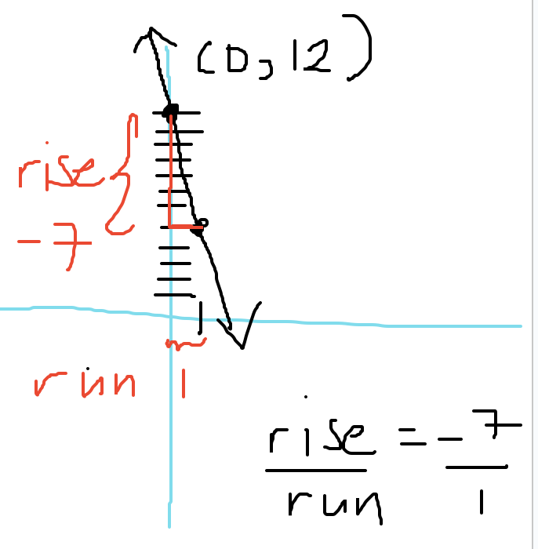

Standard form
An equation of a line is in standard form when it is written as
Ax + By = C
where A, B, and C are constants and A and B are not both zero

Example: 2x + 5y = 1

Finding Intercepts
An x-intercept is the point where the line crosses the x-axis.
A y-intercept is the point where the line crosses the y-axis.

To find any x-intercepts, let y = 0 in the equation and solve for x.
To find any y-intercepts, let x = 0 in the equation and solve for y.

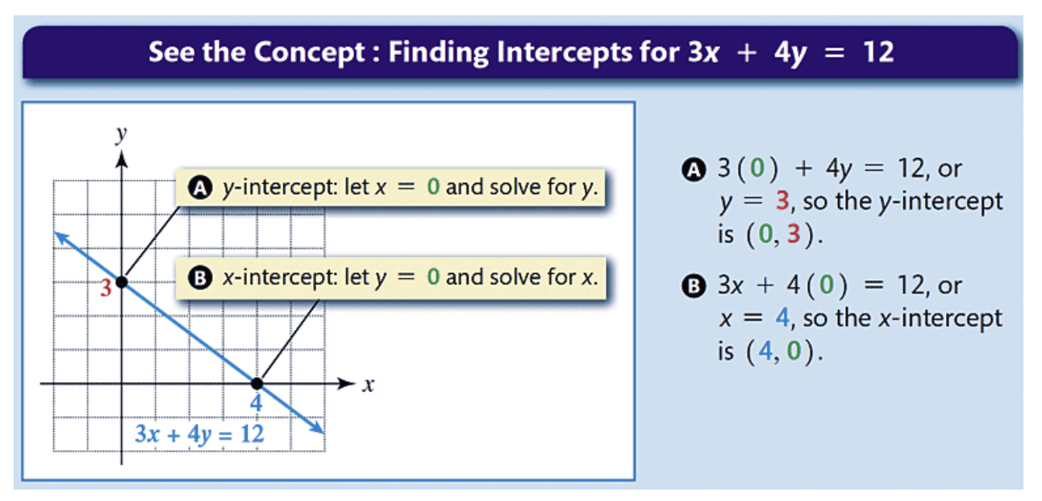

Example: Finding the x- and y- intercepts
Locate the x- and y-intercepts for the line whose equation is 4x + 3y = 6. Use the intercepts to graph the equation.

Find the x-intercept

Replace y by 0. (Set y = 0).

4x + 3(0) = 6
4x = 6
x = 6/4 = 3/2

$(\frac{3}{2},0)$ x-intercept

Find the y-intercept

Set x = 0.

4(0) + 3y = 6
3y = 6
y = 2
(0, 2) y-intercept

Horizontal Lines

Equation for a horizontal line: y = k. Ex: y = 5
y-intercept: (0, k) When y = 5, the y-intercept (0, 5)

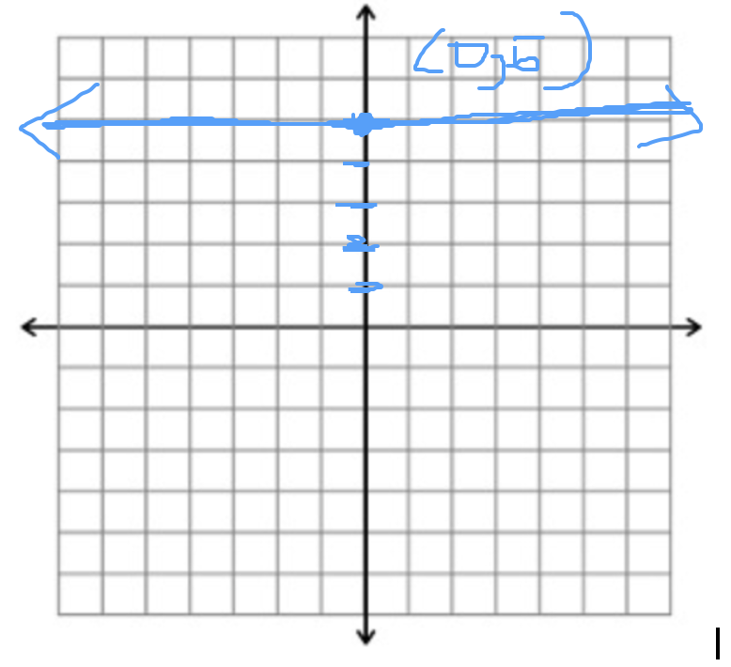

Vertical Lines
Not a function
Equation for a horizontal line: x = k Ex: x = 2
x-intercept: (k, 0) When x = 2, the x-intercept is (2, 0)
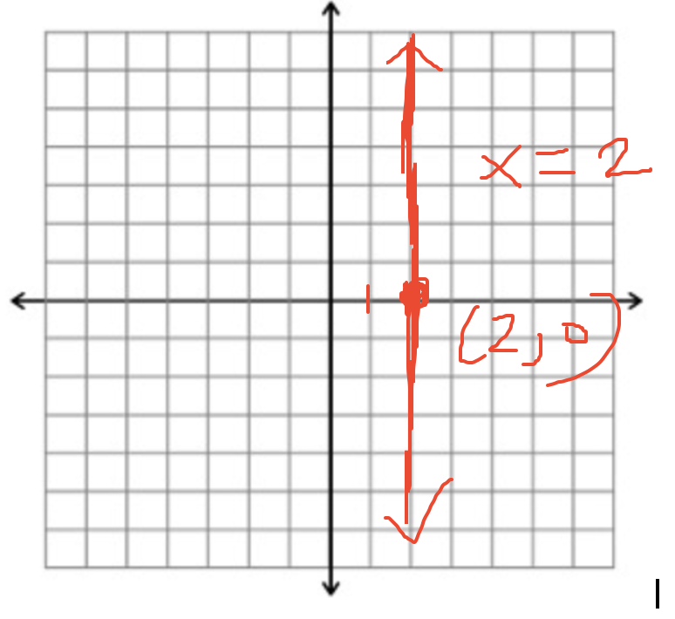

Parallel and Perpendicular Lines
Two lines are parallel if they do not intersect. Parallel lines have the same slope.
Two lines are perpendicular if they form a right angle. The slope of perpendicular lines multiply to -1.

Parallel lines: They don't intersect, both lines have a slope of 3.

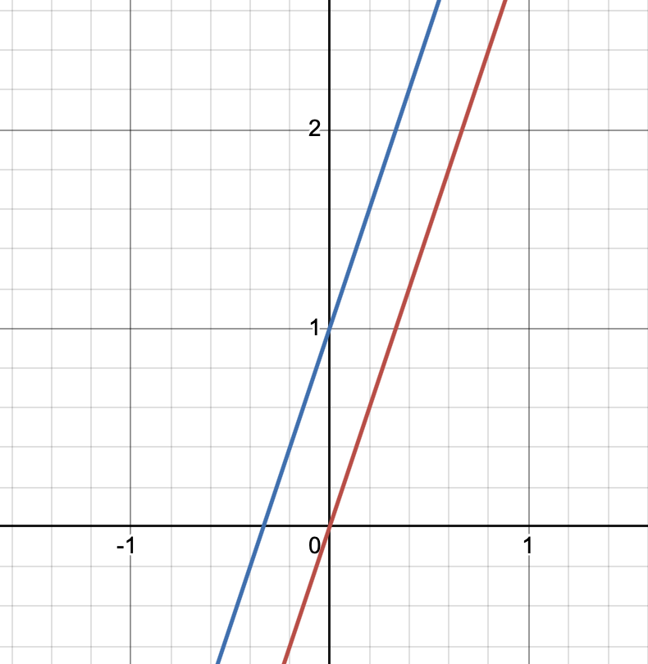

Perpendicular lines intersect at a right angle. Their slopes multiply to -1.
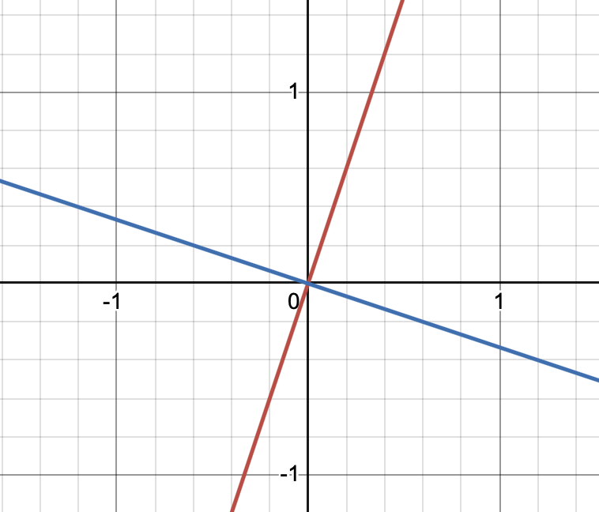

Example: Finding the equation of a perpendicular line
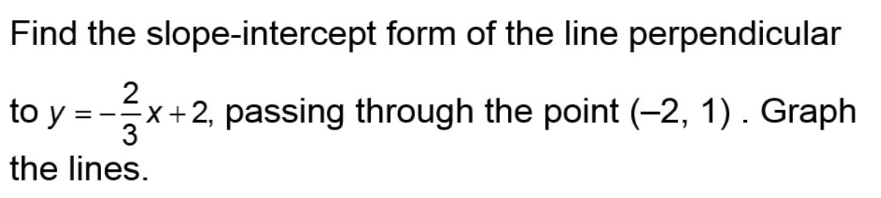

m1 = -2/3

m2 = 3/2 <- slope that we need

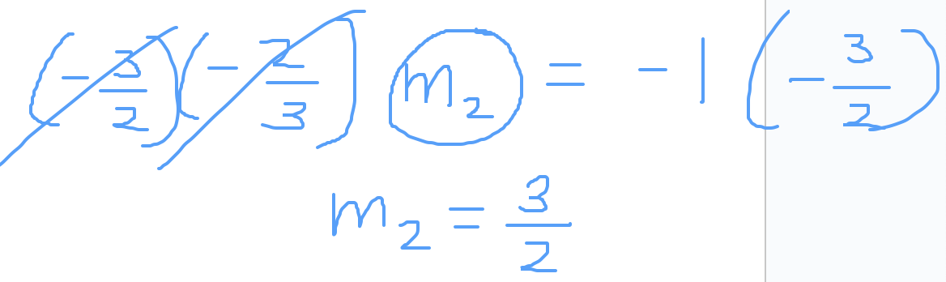

y = mx + b

y = (3/2) x + b

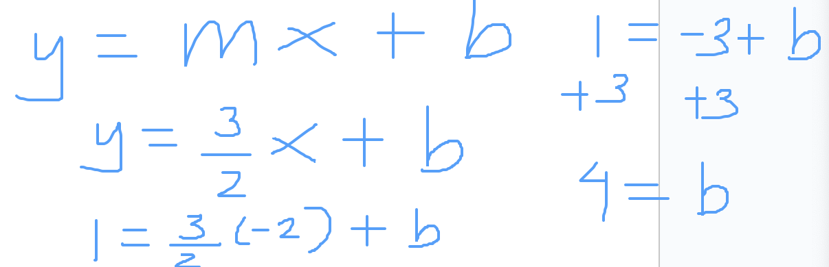

$y = \frac{3}{2}x + 4$

Follow up question: Find the equation of the parallel line to y = -2/3 x + 2 passing through the point (-2, 1).

m = -2/3 <- slope that we want

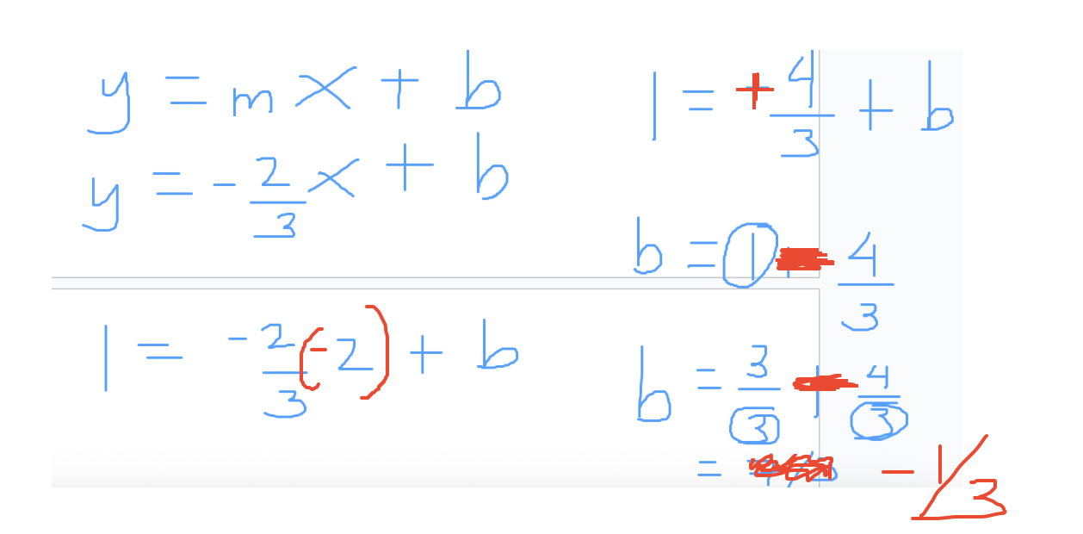

$y = -\frac{2}{3}x-\frac{1}{3}$

Case Study: Estimating Ipod Sales

Apple Corporation sold approximately 55 million iPods in 2008 and 43 million iPods in 2011. (Refer to the introduction of this section.)
a. Find the point-slope form of the line passing through (2008, 55) and (2011, 43). Interpret the slope of the line as a rate of change.
b. Sketch a graph of the data and the line connecting these points.
c. Estimate sales in 2010 and compare the estimate to the true value of 50 million. Did your answer involve interpolation or extrapolation?
d. Estimate sales in 2023. Discuss the accuracy of your answers. Did your answer involve interpolation or extrapolation?

Definitions
Interpolation occurs when we estimate values between given data points.
Extrapolation occurs when we estimate values that are not between the given data points.
Interpolation is usually more accurate than extrapolation.

